Appendix T: Resilience Mapping
Table A6-1: Niche Survey Points
Management Domain | Area | Survey points | Description
BOAs | BOA-D | 059 | White Box grassy woodland
 |  | 060 | Track maintenance
 |  | 061 | Regenerating shrubland in Ironbark
 |  | 062 | White Box grassy woodland
 |  | 063 | Prickly pear
 |  | 064 | Ironbark - Cypress forest
 | BOA-E | 065 | Red Gum - Ironbark – Cypress
 |  | 067 | Red Gum - Ironbark – Cypress
 |  | 068 | Track maintenance
 |  | 069 | Grey Gum - Blakelys – Ironbark
 |  | 070 | Acacia regrowth
 |  | 071 | Grey Gum - Blakelys – Ironbark
 |  | 072 | Gully and dams
 |  | 073 | Regenerating native pasture
 |  | 074 | Regenerating shrubland
 |  | 075 | Drainage gully into farm dam
 |  | 076 | Disused dwelling and yard
 |  | 077 | farm dam and adjacent quarry
 |  | 078 | White Box grassy woodland
 |  | 079 | Disturbed native pasture
 |  | 080 | White Box grassy woodland
 |  | 081 | White Box grassy woodland
 |  | 082 | Blakelys Red Gum gully forest
 |  | 083 | Regenerating pasture with adjacent Blakelys
 |  | 084 | Surrounding overstorey regenerating
 |  | 085 | Regenerating ground and shrub layer in Angophora forest
 |  | 086 | Native pasture in YB, Angophora, Blakelys
 |  | 087 | Native pasture in YB, Angophora, Blakelys
 |  | 088 | Regenerating WB and Ac. implexa in Native Pasture
ECAs | ECA-A | 052 | Regenerating native pasture
 |  | 053 | Recruitment of Blakelys Red Gum
 |  | 057 | Disturbed native pasture - adjacent box gum woodland
 |  | 058 | Disturbed native pasture - adjacent box gum woodland
 |  | 089 | Pig rutting
 | ECA-B | 027 | Gullying naturally stabilising with native herbs and sedges, some scars
 |  | 028 | Lomandra sedgeland
 |  | 029 | Riparian zone of Box Gum and with recovering gully scars
 |  | 031 | Carex sedgeland flood channel adjacent to Box Gum, 50/50 weed to native
 |  | 032 | Riparian zone of Box Gum and with recovering gully scars
 |  | 033 | Powerlines outside old homestead
 |  | 034 | Patersons curse under powerlines
 |  | 036 | Phragmites/Typha wetland
 |  | 037 | Native pasture
 |  | 038 | Regeneration on valley floor
 |  | 039 | Regenerating Box Gum
 | ECA-C | 049 | Regenerating woodland and pasture
Regeneration Areas | Regeneration Area 1 | 010 | Exotic pasture with WB paddock trees
 |  | 011 | Exotic pasture
 |  | 012 | Patch of native groundcover with adjacent Box Gum in road reserve just outside of Regeneration Area
 |  | 013 | Native pasture
 |  | 014 | Riparian zone of Box Gum and with recovering gully scars just outside of Regeneration Area
 |  | 024 | Native pasture
 |  | 025 | Drainage swale in native pasture
 |  | 026 | Erosion scar on steep slope, possibly over-grazing
 | Regeneration Area 2 | 053 | Recruitment of Blakelys Red Gum in ECA-A
 |  | 054 | Native pasture in YB, Angophora, Blakelys Red Gum
 |  | 055 | Disturbed native pasture in Box Gum
 |  | 056 | Recovering erosional scars on slope
 | Regeneration Area 3 | 021 | Native pasture (Regeneration Area 8)
 |  | 022 | Native pasture (Regeneration Area 7)
 |  | 023 | Box Gum recruitment on edge of forest stand with sifton bush (Regeneration Area 7)
 | Regeneration Area 4 | 035 | Degraded electricity easement
 | Regeneration Area 5 | 040 | Native pasture
 |  | 043 | Exotic pasture under power lines
 |  | 044 | Exotic pasture with patersons curse
 | Regeneration Area 6 | 015 | Exotic pasture
 |  | 016 | Regrowth shrubland - Map unit 8 (outside Regen Area 6)
 |  | 017 | Native pasture
 |  | 018 | Native pasture
 | Regeneration Area 9 | 041 | Box Gum knoll adjacent to grazed paddock
 |  | 042 | Regenerating BGW

Representative photos of Management Domains (taken May 2014)
BOA-D
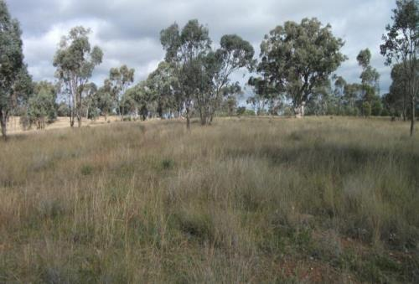

BOA-E
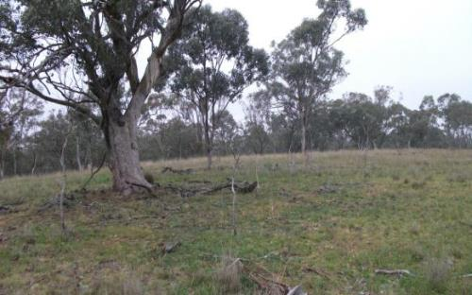

ECA-A

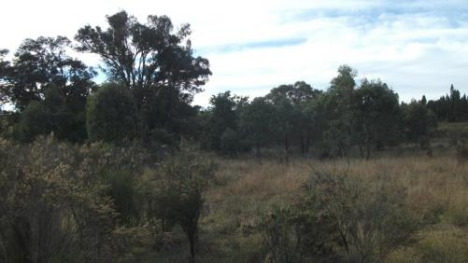

ECA-B
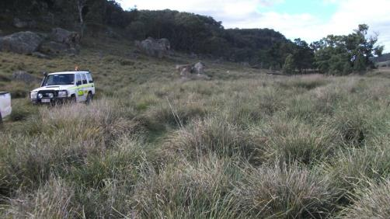

ECA-C
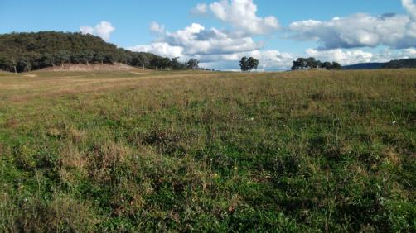

Regeneration Area 1
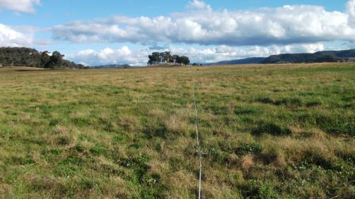

Regeneration Area 2
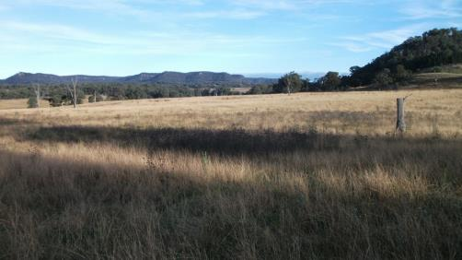

Regeneration Area 9
